**SCREENSHOOT**

# PEMROGRAMAN WEB DAN MOBILE 1



|  |  |
| --- | --- |
| **NAMA :** | **A.IRWIN PUTRA PANGESTI** |
| **NIM :** | **223020503162** |
| **KELAS :** | **1 (AP 1)** |
| **MODUL :** | **V**  (**DART)** |

1. **Soal 1**

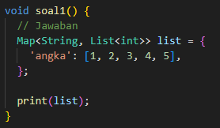

Output:



1. **Soal 2**

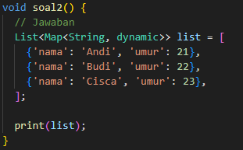

Output:



1. 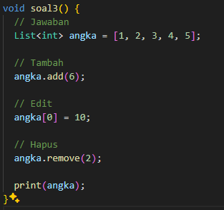**Soal 3**

Output:

